In this guide I will show hot to calculate values to be used in the keywords DEDEX VALENCE and ELCORE. As an example, I will calculate values to be used to study channeling of 2 MeV protons channeled in a silicon crystal.
- Download SRIM from http://www.srim.org/. After installing SRIM on your pc, make it to start, you will get a window like this one. Here click the button “Stopping / Range Tables”.
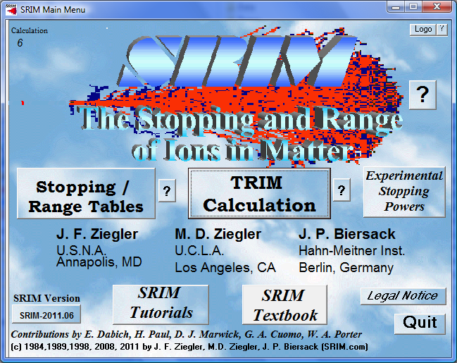
I twill open a window like this one
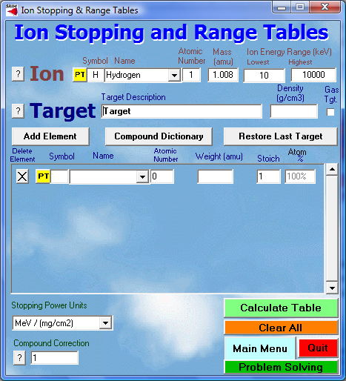
- In the field “Ion” click the button “PT”, a period table will open. Here you have to select the ion which will be subject to channeling. Here I select Hydrogen. Then fill the fields “Ion Energy Range” with an interval energy which includes the energy to which you are interested. In this example, I consider hydrogen ions of energy 2 MeV, so I put 1900 KeV as lowest energy, and 2100 KeV as highest energy.
Now, in the field “Target”, click the button “PT”, a periodic table will open up. Here you have to select the material of which the crystal is made. I select silicon. The window will assume this aspect
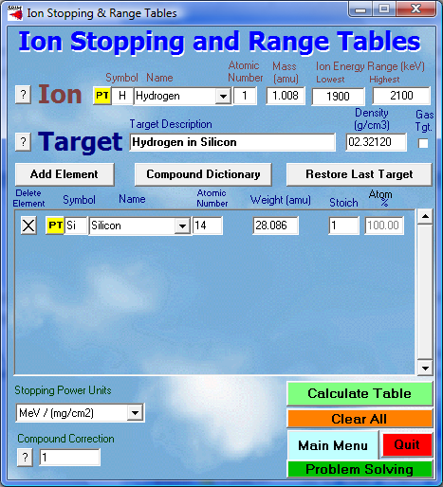
- Now click “Calculate Table”, a window with calculation results will open up
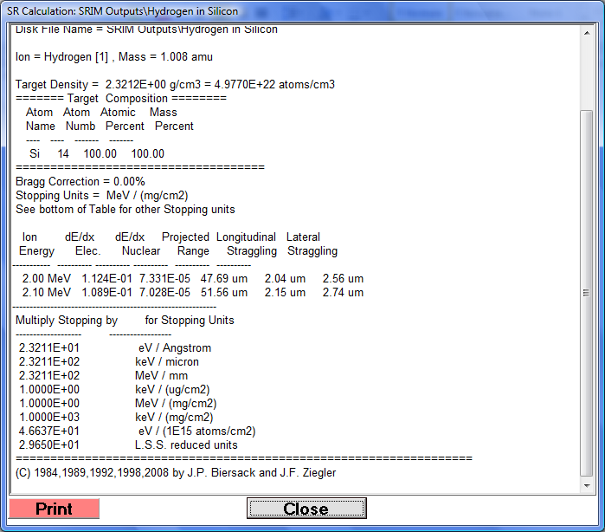
- Here it is calculated that dE/dx due to interaction with electrons (dE/dx Elec.) for 2 MeV protons interacting with silicon is 1.124E-1 MeV(mg/cm²). FLUX is expressing energy losses in eV/A, so It’s sufficient to multiply the value provided by SRIM by the target density. Being silicon density 2.3212 g/cm³ in this case energy loss expressed in eV/A is 1.124E-1*2.3211E+1=2.609 eV/A.
Ok, now we obtained dE/dx due interaction between a 2MeV proton and electrons of silicon, now we have to implement this value in FLUX, which distinguishes electronic energy losses due to interaction with core electrons and with valence electrons, i.e. it is necessary to calculate contribution coming from such electrons.

- As first, we calculate energy losses due to interaction with core electrons. We use the program “dettmann” in directory the directory “FLUX/BIN”.
Prior to start this program, let me to recall you that the electronic configuration of silicon is
1s² 2s² 2p⁶ 3s² 3p²
The shell 1s contain 2 electrons, the shell 2s contains 2 electrons, the shell 2p contains 6 electrons, the shell 3s contains 2 electrons and the shell 3p is filled with 2 electrons.
Valence electrons are in the shell 3s² 3p², core electrons are the ones in the shells 1s² 2s² 2p⁶. From here we will consider only core electrons. Now we need electrons binding energies for core electrons.
Electrons in the shell 2p has binding energy of 108.22 eV [REF??], electrons in the shell 2s has a binding energy of 150.85 eV[REF??], electrons in the shell 1s has binding energy of 1823.7 eV[REF??].
Ok, can start the program dettmann

Dettmann will ask, in the order, the following input data:
“Z ion”, in our case we input “1”
“Ion mass”, in our case we input “1.0078” (in atomic units)
“Energy (MeV)”, the energy of the channeled ion, in our case we input “2”
“BMAX (ANGSTROM)” We set it at value “2”
“NR of electrons”, here we input the number of electrons in the outer shell (2p), i.e. “6”
“E-binding (eV)”, here we put the binding energy of electrons in the shell 2p, i.e. “108.22”
Dettmann will give the following output
CONTRIBUTION OF THIS SUBSHELL, IN eV
40.36065 37.12901 33.24940 29.27266 25.44333
21.87954 18.64012 15.75101 13.21692 11.02609
9.15525 7.56871 6.24957 5.14708 4.23459
3.48213 2.86681 2.35692 1.94126 1.60098
1.32232 1.09377 0.90630 0.75224 0.62539
0.52089 0.43459 0.36320 0.30403 0.25490
0.21403 0.17995 0.15152 0.12777 0.10784
0.09114 0.07710 0.06530 0.05535 0.04689
0.03988 0.03390 0.02883 0.02454 0.02090
0.01782 0.01520 0.01297 0.01107 0.00946

And then ask the same information for the remaining shells
“NR of electrons”, here we input the number of electrons in the outer shell (22), i.e. “2”
“E-binding (eV)”, here we put the binding energy of electrons in the shell 2s, i.e. “150.85”

Dettmann will give the output
CONTRIBUTION OF THIS SUBSHELL, IN eV
18.30179 16.34402 14.10299 11.90128 9.86859
8.06355 6.50644 5.19503 4.11266 3.23391
2.52994 1.97231 1.53386 1.19144 0.92497
0.71837 0.55835 0.43456 0.33872 0.26451
0.20695 0.16227 0.12747 0.10036 0.07919
0.06257 0.04955 0.03931 0.03123 0.02486
0.01982 0.01582 0.01265 0.01012 0.00811
0.00651 0.00523 0.00420 0.00338 0.00272
0.00219 0.00177 0.00143 0.00115 0.00093
0.00075 0.00061 0.00049 0.00040 0.00032

And then ask the same information for the last shell (1s)
“NR of electrons”, here we input the number of electrons in the inner shell (1s), i.e. “2”
“E-binding (eV)”, here we put the binding energy of electrons in the shell 2p, i.e. “1823.7”.
Dettmann will give the output
CONTRIBUTION OF THIS SUBSHELL, IN eV
62.16310 18.35625 4.38977 0.94472 0.19187
0.03764 0.00722 0.00136 0.00025 0.00005
0.00001 0.00000

We inputted the contributions coming from all the core electrons. Dettmann continues to ask as input
“NR of electrons”, in this case we input “0” and dettmann answers with this output
SUM OVER ALL SUBSHELLS, B= 1..50 *(BMAX/50)
120.82553 71.82927 51.74216 42.11866 35.50380
29.98073 25.15377 20.94740 17.32983 14.26005
11.68519 9.54102 7.78343 6.33852 5.15956
4.20050 3.42515 2.79148 2.27998 1.86549
1.52928 1.25604 1.03377 0.85260 0.70459
0.58346 0.48414 0.40251 0.33526 0.27976
0.23385 0.19577 0.16417 0.13789 0.11595
0.09764 0.08233 0.06950 0.05873 0.04961
0.04208 0.03567 0.03026 0.02570 0.02184
0.01857 0.01581 0.01346 0.01147 0.00979

Those last numbers must be used as input for the keyword ELCORE, i.e.
ELCORE
120.82553 71.82927 51.74216 42.11866 35.50380
29.98073 25.15377 20.94740 17.32983 14.26005
11.68519 9.54102 7.78343 6.33852 5.15956
4.20050 3.42515 2.79148 2.27998 1.86549
1.52928 1.25604 1.03377 0.85260 0.70459
0.58346 0.48414 0.40251 0.33526 0.27976
0.23385 0.19577 0.16417 0.13789 0.11595
0.09764 0.08233 0.06950 0.05873 0.04961
0.04208 0.03567 0.03026 0.02570 0.02184
0.01857 0.01581 0.01346 0.01147 0.00979

We calculated contribution to electronic energy losses coming from core electrons

- Ok, now we have to calculate the contribution to electronic energy losses coming from interaction with valence electrons (keyword DEDX VALENCE). Let’s prepare an input file and put the keywords
DEDX VALENCE
0 0
ELCORE
120.82553 71.82927 51.74216 42.11866 35.50380
29.98073 25.15377 20.94740 17.32983 14.26005
11.68519 9.54102 7.78343 6.33852 5.15956
4.20050 3.42515 2.79148 2.27998 1.86549
1.52928 1.25604 1.03377 0.85260 0.70459
0.58346 0.48414 0.40251 0.33526 0.27976
0.23385 0.19577 0.16417 0.13789 0.11595
0.09764 0.08233 0.06950 0.05873 0.04961
0.04208 0.03567 0.03026 0.02570 0.02184
0.01857 0.01581 0.01346 0.01147 0.00979

I.e., we set at zero the contribution coming from valence electrons.
Now, we run fluxchk giving as input the file which we are going to use for our simulation.
Fluxchk gives the following output
LAYER 1: --- ENERGY LOSS ESTIMATES ---
atomic volume, in angstrom^3 20.024
evaluated at T= 2.000 MeV
random stopping power in eV/A, core 1.305 1.305
random stopping power in eV/A, valence 0.000
random stopping power in eV/A, total 1.305
Ziegler values T= 2.000 MeV 24.162 24.162
Ziegler values T= 1.500 MeV 27.474 27.474
Ziegler values T= 1.000 MeV 31.858 31.858
There are three important values: “random stopping power in eV/A, core”, “random stopping power in eV/A, valence” and “random stopping power in eV/A, total”.
What does it means “Ziegler values” ??
The last parameter, “random stopping power in eV/A, total” has a value of 1.305 eV/A. We know from SRIM that this value should be 2.609 eV/A. We perform the operation “(2.609-1.305)/2=0.652” and we modify the input file of flux in the following way

DEDX VALENCE
0.652 0.652
ELCORE
120.82553 71.82927 51.74216 42.11866 35.50380
29.98073 25.15377 20.94740 17.32983 14.26005
11.68519 9.54102 7.78343 6.33852 5.15956
4.20050 3.42515 2.79148 2.27998 1.86549
1.52928 1.25604 1.03377 0.85260 0.70459
0.58346 0.48414 0.40251 0.33526 0.27976
0.23385 0.19577 0.16417 0.13789 0.11595
0.09764 0.08233 0.06950 0.05873 0.04961
0.04208 0.03567 0.03026 0.02570 0.02184
0.01857 0.01581 0.01346 0.01147 0.00979

Now we run again fluxchk and we obtain the following output
LAYER 1: --- ENERGY LOSS ESTIMATES ---
atomic volume, in angstrom^3 20.024
evaluated at T= 2.000 MeV
random stopping power in eV/A, core 1.305 1.305
random stopping power in eV/A, valence 1.304
random stopping power in eV/A, total 2.609
Ziegler values T= 2.000 MeV 24.162 24.162
Ziegler values T= 1.500 MeV 27.474 27.474
Ziegler values T= 1.000 MeV 31.858 31.858

Now, the parameter “random stopping power in eV/A, total” takes the value calculated by SRIM, so we obtained the values to be used for the keywords ELCORE and DEDX VALENCE.

DEDX VALENCE
0.652 0.652
ELCORE
120.82553 71.82927 51.74216 42.11866 35.50380
29.98073 25.15377 20.94740 17.32983 14.26005
11.68519 9.54102 7.78343 6.33852 5.15956
4.20050 3.42515 2.79148 2.27998 1.86549
1.52928 1.25604 1.03377 0.85260 0.70459
0.58346 0.48414 0.40251 0.33526 0.27976
0.23385 0.19577 0.16417 0.13789 0.11595
0.09764 0.08233 0.06950 0.05873 0.04961
0.04208 0.03567 0.03026 0.02570 0.02184
0.01857 0.01581 0.01346 0.01147 0.00979

